**SSCBS**

**MAYANK CHOPRA**

**ROLLNO -23719**

**Lab6) – ZAP PROXY :VULNERABLE & OUTDATED COMPONENTS**

**Assignment for testing the website for owasp 6 –**

**Target website -ginandjuice.shop**

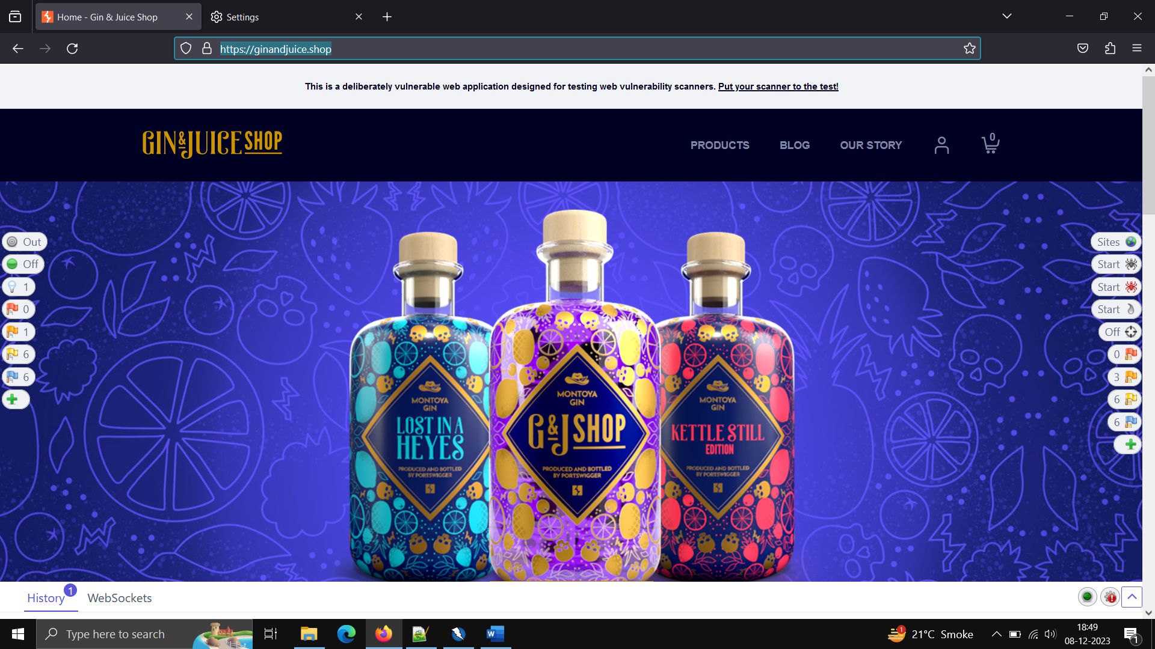

**Vulnerability found – outdated angular version**

